Data Engineer FellowShip with Bytewise Limited.

Meer Danish 16/March/2023

horizontal line

Task # 5

# What is Full Load?

In the context of Data Engineering, Full Load refers to a type of data integration strategy where all the available data is extracted from source systems and loaded into a target system in a batch process. This approach involves a complete replacement of the data in the target system with the new data from the source systems, rather than performing incremental updates.

While Full Load can be a useful strategy for certain data integration scenarios, it can be time-consuming and resource-intensive. Incremental Loading, which involves only loading new or updated data into the target system, is often used as an alternative strategy to reduce processing time and minimize the impact on the source systems.

# 

# What is incremental load?

Incremental load in data engineering is the process of updating a database or data warehouse with only new or modified data since the last load, rather than reloading the entire dataset. This is done to optimize performance and reduce the time and resources required to update data.

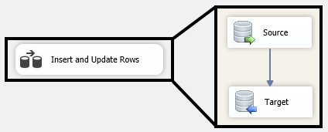

# What is a Historical Load?

Historical load in data engineering is the process of loading large volumes of historical data into a database or data warehouse, with the aim of providing a complete historical record of data for trend analysis, forecasting, and other analytical purposes. It is often performed as a one-time process and can be complex and time-consuming.